

**Part IV- The Commitment to Equity Assessment Tools**

[Commitment to Equity Handbook](http://www.commitmentoequity.org/handbook/)

[Estimating the Impact of Fiscal Policy on Inequality and Poverty](http://www.commitmentoequity.org/handbook/)

[Brookings Institution and CEQ Institute](http://www.commitmentoequity.org/handbook/)

[Nora Lustig (editor](http://www.commitmentoequity.org/handbook/))

March 1, 2018

**Checking Protocol**

Sandra Martinez-Aguilar, Adam Ratzlaff, Maynor Cabrera, Cristina Carrera, and Sean Higgins

This document presents a brief description the CEQ Checking Protocol and instructions for its use.

The Checking Protocol is used during the quality control stage of a CEQ assessment. It provides analysts with instructions for checking the completeness and accuracy of an assessment and its constituent parts. It includes modules on (a) common sense checking, (b) cross-checking with publicly available data from administrative or other sources (e.g., the World Bank’s POVCAL database), (c) automated checking, and (d) technical checking.

Table of Contents

CEQ Master Workbook 2017 3

Steps for checking the completeness and accuracy of Assessment results 4

1. Verify all components were received 4

2. Verify that files have been named according to the following conventions: 4

3. Check MWB Sections A, B, and C - Worksheet names are in *italic blue*. 5

Section A 5

Section B 7

Section C 11

4.- Check MWBs E 14

E2. Population for Core Income Concepts 18

E3. Lorenz for Core Income Concepts 18

E4. Inequality of Opportunity for Core Income Concepts 19

E5. Fiscal Impoverishment 19

E6. Fiscal Gain to the Poor 20

E10. Concentration Values for Core Income Concepts 20

E11. Fiscal Interventions Concentration Values (One for each core income concept) 21

E12. Lorenz for Extended Income Concepts 21

E13. Marginal Contributions, Size & Marginal Effects 22

E14. Effectiveness 22

E18. Coverage 23

E19. Coverage (target) 23

E20. Educational Enrollment 24

E21. Infrastructure Access 24

E22. Household Socio-Demographic Indicators 25

E23. Individual Socio-Demographic Indicators 25

E24. Lorenz Curves 25

E25. Concentration Curves 26

E26. Cumulative Distribution Functions 26

E27. Fiscal impoverishment and gains to the poor curves 26

E28. Assumption Testing 26

ANNEX 1 28

Instructions on how to use the “Linking” program 28

# CEQ Master Workbook 2017

The CEQ Master Workbook (MWB) 2017 is a multi-tab Microsoft Excel worksheet that includes detailed background information on a country’s recent economic, political, and social history and context, in addition to a description of the information used to conduct the CEQ assessment, and assessment results. There are six MWB sections grouped in 30 Excel worksheet tabs:

1. MWB Section ABC:

* Section A. Country Context contains information on a country’s recent macroeconomic, political and socio-economic – including poverty and inequality – history.
* Section B. Data includes a description of the microdata – the household income and expenditure survey or the household budget survey – and fiscal data utilized in the fiscal incidence analysis.
* Section C. Methodology is a detailed description of the methods, algorithms, empirical rules, and assumptions used to allocate fiscal expenditure and revenue collection instruments in the microdata.

1. MWB Section D:

* Section D. Summary of Results contains a summary of assessment results.

1. MWB Section E (which contains 27 separate Excel worksheets numbered E1 to E28):

* Section E. Output Tables contains unabridged assessment results[1] covering, among other things, (1) the impact of fiscal policy on inequality and poverty; (2) the extent of progressivity or regressivity of fiscal transfers or revenue collections; (3) the marginal contributions of fiscal policy elements to overall inequality or poverty reduction from fiscal policy; and (4) effectiveness indicators comparing the poverty or inequality impact of fiscal policy elements to one another and to expenditure magnitudes

1. MWB Section F:

* Section F (when applicable) consists of a summary of results by pre-defined subgroups (typically ethno-racial groups).

# Steps for checking the completeness and accuracy of Assessment results

The Checking protocol is used during the quality control stage. This section of CEQ Handbook is addressed to whoever is involved in checking the completeness and accuracy of CEQ Assessment results: either the authors of the CEQ Assessment or staff members of the CEQ Institute. It is important to note that there are two scenarios: Pensions as Deferred Income (PDI), and Pensions as Government Transfer (PGT) (see chapter 1 of this Handbook)[2] Similarly, the CEQ assessment should consider using PPP conversion factor 2005 and 2011 to estimate international poverty lines and income groups.

## 1. Verify all components were received

1. One completed MWB Section ABC file.
2. Four (or eight) MWB Section D files which should include:
   1. Two copies of section D in per capita terms using the 2005 PPP conversion factor: one for each scenario of public contributory pensions: PDI and PGT.
   2. Two additional copies of section D in per capita terms using the 2011 PPP conversion factor (one for each scenario: PDI and PGT).
3. Two (or more) copies of Section E of the MWB:
   1. One copy in per capita terms using the 2005 PPP conversion factor
   2. The other section E in per capita terms using the 2011 PPP conversion factor.

If a “per adult equivalent” scale was used in the construction of the baseline version of the Assessment, or additional sensitivity analyses were generated, additional copies of section E of the MWB may be received.

If the study included disaggregation by ethnic group, rural-urban, gender, etc., you should also receive

1. At least two copies of section D of the MWB for each group (one for each treatment of contributory pension) using 2005 PPP
2. At least two copies of section D of the MWB for each group (one for each treatment of contributory pension) using 2011 PPP
3. At least one copy of section E of the MWB per group using 2005 PPP
4. At least one copy of section E of the MWB per group using 2011 PPP
5. At least two Section F workbooks
   1. one for each treatment of contributory pension using 2005 PPP
   2. one for each treatment of contributory pension using 2011 PPP

## 2. Verify that files have been named according to the following conventions:

_**[ISO[3] Three Letter Country Code]_[Group]_[Scenario]_[Project]_[MWB Version]_ [Section Letter and Number]_[Delivery Date]_[Scale]**

Example for Chile:

ISO Three Letter Country Code: CHL

Group: Three letter group abbreviations, e.g., National (NAT), Indigenous (IND), White (WHT).

Scenario: Use the following three-letter codes referring to the treatment of Contributory Pensions: as Deferred Income (PDI) or as Government Transfer (PGT) or other sensitivity analysis scenario.

Project: this normally refers to the acronym of the institution financing the Assessment, e.g. WB, ICEFI, IDB, CEQI, etc.

Version: e.g., MWB2016 or MWB2017.

Section Letter and Number: e.g. ABC, D, E1, E2, E10, or F, among others.

Delivery Date: IMPORTANT: always include the actual date of production so that results can be compared to previous and future “runs”. The format for the date must be as follows:

mmmdd_yyyy

where:

mmm are three first letters of the month e.g. Jun

dd correspond to the two digits of the day e.g. 19

yyyy corresponds to the four digits of the year e.g. 2017

Scale: for per-capita (pc) or per-adult equivalent (pa) terms.

The name of one of the files in the case of Chile would be:

_CHL_IND_PDI_IDB_CEQMWB2017_D_Jun19_2015_pc.xls

## 3. Check MWB Sections A, B, and C

#### Title

1. **Completeness**
   1. Check that the Title page is completed and that it matches the nomenclature of the file. The Title page should include:
      1. Country
      2. Survey year
      3. Group: this can be national, indigenous, white, African, rural, urban, women, men, etc.
      4. Team: Authors’/Researchers’ names
      5. Project: this normally refers to the organization financing the specific CEQ Assessment, e.g. WB, ICEFI, IDB, CEQI, etc.
      6. Date of Submission: IMPORTANT: always include the actual date of production so that results can be compared to previous and future versions of the study.
2. **Accuracy/Coherence**
   1. Make sure that the information in the file name (see the file-naming conventions in Step 2 above) and that it matches the information of the Title page

#### Country Team Info

1. **Completeness** - Make sure that the information is complete and clear.
2. **Accuracy/Coherence**
   1. Verify that information matches that provided on the Title page.

### Section A

#### A1. Country Context

1. **Completeness**
   1. Make sure that all of the information has been completed.
   2. Information provided should match the year of the analysis.
   3. All information presented on this sheet comes from secondary sources. Check that sources are described and properly cited.
   4. Spot check information against original sources (rows 9 through 16 only).
2. Using a simple internet search or an on demand news/media aggregator, check to see if any major events (political, economic, social, environmental, natural disaster) occurred in the years prior to the household survey and expenditure or budget data that is being used in the analysis. Make sure that the information (provided in rows 18 through 34 only) is clear, that the sources are reliable, and that the event (or events) can be re-confirmed in additional reputable sources.
3. Check the sources provided in rows 36-55 and verify that the information provided is accurate.

#### A2. Socio-Demographic Characteristics: Education, Health & Other Sociodemographic Indicators

1. **Completeness** - Make sure that all information has been provided and appropriately cited.
2. **Accuracy/Coherence**
   1. Check secondary sources (the World Bank’s databases, for example) to determine if the total population that appears in this sheet and in sheet E2 are *similar* (they need not be equal).
   2. Randomly choose two or three indicators from each category —Population, Education, Health and Employment—and check results against original sources. For example, for Population category you should check if the total of the urban and rural populations presented in this sheet are the same numbers as those that appear in the source provided in G20 and G30.
   3. Check that the sum of the components adds up to the corresponding total. In particular, check that:
      1. The sum of male and female population adds up to the total population.
      2. The sum of urban and urban population adds up to the total population.

#### A3. Evolution of Inequality and Poverty

1. **Completeness**
   1. Make sure that the information and sources have been completed.
   2. If subsections are blank/missing:
      1. A missing row (missing one indicator for all years) should be flagged so that the data can be added later.
      2. A missing column (missing all indicators for one year) or a missing cell (missing one indicator for one year) may indicate that data was not collected in that year (for example, poverty indicators are often generated only for years when the household survey was conducted). All missing data should be confirmed in conversations with the country team.
2. **Accuracy/Coherence**
   1. Check “Gini”, “Headcount National Povline” for moderate poverty line and “Moderate poverty line in daily PPP” against original sources and against external sources such as povcal, SEDLAC.
   2. Spot check some values for logical consistency (Do the numbers make sense? What do they imply?) For example, poverty and inequality tend to decrease when you move from market income to final income, this does not happen always, but if it does not happen, make sure that the information is correct.
   3. Check that these relationships (at a minimum) hold:
      1. If y>x, headcount $y PPP> headcount $x PPP
      2. At each poverty line, Headcount>Poverty Gap>Squared PG
   4. Compare estimated poverty and inequality measures with external sources, like POVCAL. According to EUROMOD(2017) differences may arise due to differences in methodology, the following sources of bias are justified: (i)sample adjustments; (ii)differences in the concept of disposable income; (iii)data imputations; and others, like if simulations were included or assumptions made.

#### A4. Evolution of Macroeconomic Performance, Government Revenues and Government Expenditures

1. **Completeness**
   1. Make sure that the information and sources have been completed.

1. **Accuracy/Coherence**
   1. Using formulas in Excel) to check that the per capita values are correct. For example, take the total GDP, divide that by the population, and check if the result matches the GDP per capita. Results should be accurate to within 1 percent of your calculation as both the numerator (GDP) and the denominator (population) may differ slightly depending on sources.
   2. Check with formulas whether growth in real GDP and real and nominal GDP per capita are correct.
   3. Check with formulas that the inflation rate is consistent with yearly Consumer Price Index values.
   4. Rows 10, 11 and 12 (under row 9 that says “*In Survey (just fill in for year of survey)”*) need to be filled in using the survey. As such, only information for the year of the survey should be completed. Check that the total population that appears here is the same total population that appears in E2.
   5. Check that the ratios (rows 14, 15 and 16) are calculated with formulas and formulas are correct
   6. Check the authors are reporting amounts in LCU for rows 19, 26, 27, 29, 36, 37, 42, 43, 53 and 54.
   7. Check against the World Development Indicators (WDI) that authors are reporting amounts in current US$, for rows 21, 31, 38, 44, 82, and 83.
   8. Check against the WDI that authors are reporting amounts in constant 2005 US$ for rows 23, 33, 40 and 46.
   9. Check against the WDI that authors are reporting amounts in constant 2011 US$ for rows 22, 32, 39 and 45.
   10. Check rows 32, 33, 45, 46, 55, 56, 57, 58, 68, 69, 70, and 71 against the original source that must be the WDI.

### Section B

#### B1. General Survey Information

1. **Completeness** - Make sure that the information and sources (where relevant) are complete.
2. **Accuracy/Coherence**
   1. All the information presented on this sheet must be consistent with the information presented on sheets B3 (see below) and C1 (see below).
   2. D36 provides information about imputed rents for those who live in owner-occupied housing. Worksheet C1 (see below) will contain information on how such values were estimated (when they are estimated). Please review the estimation described in C1 together with cell D36 (of this sheet) and flag if the estimation is a non-standard procedure or cell D36.

#### B2. Survey Questions and Variable Names

1. **Completeness**
   1. Make sure that the information is completed (please note that the *Notes* column may be blank).
   2. Authors should add/delete rows where necessary.
      1. Check that added rows are in the correct location. Correct categorization of income is necessary for accurate calculations later on.
      2. For deleted rows, compare back to original. What rows were deleted? Why? Should they be included or is it acceptable to have them deleted?
2. **Accuracy/Coherence**
   1. *Includes* should be definitional, giving a comprehensive, understanding of what the term means.

#### B3. General Government Revenues & Spending

1. **Completeness**
   1. Make sure that the information and sources are complete.
   2. Row 15: budget data year and country name should be added.
2. **Accuracy/Coherence**
   1. Check year of survey is consistent with the information in the title page and sheet B1 (cell C10).
   2. Check population, per capita GNI, PPP conversion factor and GDP in local currency matches the information presented on sheet A4 (see above).
   3. Check that, for every fiscal item listed, “Currency Amounts, Administrative Accounts” (Column C) are always greater than or equal to “Total Included in Analysis from Administrative Accounts” (Column F).
   4. Check that the spending measure “Total as percentage of GDP” of each fiscal item (for example, a Fuel Subsidy) is never higher than the spending measure “Total as percentage of GDP” of the aggregate category to which it belongs (for example, Total Subsidy Spending).
   5. Check that, for every fiscal item listed, “Total as percentage of GDP” (Column D) are always greater than or equal to “Total Included in Analysis from Administrative Accounts as % of GDP” (Column G).
   6. Check that the currency sum of fiscal items within a category is equal to the currency sum of that category. If the aggregates of columns C and G and the ratios of columns D and G are not filled in using formulas, create new columns and use formulas check the following:
      1. Total Revenue = Taxes revenues + non-tax revenue
         1. Total Taxes = Direct taxes + VAT and other indirect + Other taxes
         2. Direct Taxes = Sum of components
      2. Primary Government Spending: the sum of social spending, nonsocial spending, and contributory pensions will not be equal to the total primary Government Spending since there are other sectors such as ministry of finance, ministry of energy, etc., that are not considered into the analysis.
         1. Social spending= social protection + education + health + other social spending
            1. Social Protection = social assistance + social insurance
            2. Social Assistance = Cash Transfers + Near Cash Transfers + Noncontributory pensions
         2. Nonsocial spending = Defense spending +Indirect Subsidies + Other Non-social
   7. Check that the information from National Accounts is the budget executed as opposite to the budget approved. If not, ask the author(s) why the approved budget was used instead of the executed budget.
   8. Check that currency and unit are specified in cell C16 and check that numbers seem consistent with the specified currency and unit.
   9. Check that columns D and G have been generated using formulas (i.e., they are not inputs).
   10. Compare total revenues and total expenditure against the original source. These should be equal.

#### B4. Description of Tax System

1. **Completeness**
   1. There should be a clear, concise *narrative* describing (i) how the system works including a discussion of the applicable rates; (ii) what the main taxes are; (iii) which taxes are included in the analysis.
   2. Check that references are described and enumerated.
2. **Accuracy/Coherence**
   1. Check sheets B3 and C1 and verify all taxes marked as “included” in either B3 or C1 are described on sheet B4.
   2. Flag taxes that are NOT included for follow-up conversation with the research team.

#### B5. Description of Contributory Old-Age Pension System and Other Contributory Programs

1. **Completeness**
   1. It should be clear what contributory pension system(s) is(are) included in the market income plus pensions.
   2. Main characteristics, requirements, and benefits should be clearly described.
   3. Definition of who the target beneficiaries of each pension program should be enumerated.
   4. Each program description should include the proportion of the population affiliated with it.
   5. Mechanisms for payment should be defined.
   6. Verify that references are included and complete.
2. **Accuracy/Coherence**
   1. Check sheets B3 and C1 and verify that all taxes marked as “included” in either B3 or C1 are described on sheet B5.
   2. Flag Contributory Old-Age Pension System(s) that are NOT included for follow-up conversations with research team.

#### B6. Description of Cash Transfer Programs (including non-contributory pensions)

#### and B7. Description of Near Cash Transfer Programs (Food Rations, School Uniforms, etc.)

1. **Completeness**
   1. All cash transfer programs included in the analysis should appear in this table. Crosscheck against B3 and C1.
   2. Verify that of the following information is described for each program:
      1. Name of the program.
      2. Type of program.
      3. If the program is taxable.
      4. The target population.
      5. Total number of beneficiaries.
      6. When the program was implemented
      7. The budget
      8. Targeting mechanism - Flag if description too brief.
      9. Estimated Impact- Flag it if description too brief. If the cell is not in blank ask the author why is in blank, if the cell is not in blank make sure that the author included references.
2. **Accuracy/Coherence**
   1. Make sure that the *Number of Beneficiaries* matches the information provided on sheet C1 in columns J and I.
   2. Make sure that the *Budget* is the same as on sheet C1 in columns J and I.
   3. Make sure the program can be understood from the description given. It should included detailed information on the programs:
      1. Eligibility.
      2. Process.
      3. Amount.
   4. Flag direct transfers that are NOT included for follow-up conversation with research team.

#### B8. Description of Price Subsidies (Consumer and Producer)

1. **Completeness** – Check that all subsidies (together with references) included in the analysis should appear in this table. Crosscheck against sheets B3 and C1.
2. **Accuracy/Coherence**
   1. Make sure that the *Budget* is the same as on sheet C1.
   2. Descriptions should clearly describe:
      1. What is being subsidized.
      2. The amount or percentage of subsidy.
      3. If it is universal or targeted.
      4. Who the beneficiaries are.
      5. Requirements if any.
   3. Flag subsidies that are NOT included for follow-up conversation with the research team.

#### B9. Description of Public Education System

1. **Completeness**
   1. Check that the primary, secondary, and tertiary education levels are all described (including grade level equivalents).
   2. Check that the private education system is mentioned and compared, but public schooling is the focus. For example, if we have total enrollment rates for schooling, we would also want the percentage of students enrolled in public school.
   3. Check that Expenditure as a percentage of GDP matches the data presented on sheet B3.
   4. Verify that information on compulsory schooling laws is provided (if applicable).
   5. Check that the coverage rate is equal to the percentage attending school.
   6. Check that the enrollment and attendance rates are provided (by level, for at least public school).
2. **Accuracy/Coherence**
   1. Compare the expenditure as a percentage of GDP with the information on sheet B3.
   2. Compare coverage, enrollment and attendance rates with the information on sheet D11.

#### B10. Description of Public Health System

1. **Completeness**
   1. Verify that all programs included in the analysis are described. All programs included should be verified against the information provided on sheets B3 and C1.
   2. The following information should be included in the description of each program:
      1. A description of each sector of the public health system.
      2. Which programs are included in the analysis.
      3. The main characteristics, requirements, benefits of each program.
      4. Who the beneficiaries are.
      5. The proportion of the population affiliated with each system.
      6. What the mechanism is for payment and the amount or percentage that should be paid for which type of income.
      7. Program expenditure as a percentage of GDP.

It is possible that this information is not available to the researcher, so if any information is missing, flag it for a follow-up conversation with the research team.

1. **Accuracy/Coherence**
   1. Compare the expenditure as a percentage of GDP with the information on sheet B3.
   2. Compare coverage with the information given on sheet D9a.
   3. Be sure that information is complete, clarified, and consistent. You need to understand how the health system works from this description and what is included in the analysis.
   4. Flag what is NOT included in the analysis, different from the private sector, for follow-up conversation with the research team.

#### B11. Description of Public Housing Subsidies

* + - 1. Follow checks for sheet B9.
      2. Check consistency with sheets C1 and B3.

#### B12. Other

1. Objective facts not covered elsewhere in Section B.
2. Acceptable to be blank.
3. If facts are here, check they belong here as opposed to in section C methodology. This sheet should focus on descriptions.

### Section C

#### C1. Construction of Income Concepts

Note that this sheet is **extremely** **important** and serves as a guide for the rest of the analysis.

1. **Completeness**
   1. Make sure that the information is complete.
   2. Check that the information provided on sheet B3 is included and disaggregated here.
   3. Check all that all individual taxes, not just aggregate categories are included.
   4. Other direct transfers need to be fully described:
      1. Check that we have a comprehensive list of all direct transfer programs and not a list of examples.
      2. This sheet should NOT say things like “programs like…” or “programs such as…”
   5. Make sure that information includes Specifics! Such as budget per year, percentage as a share of budget and GDP, expenditure per student, etc.
      1. E.g. for in-kind education, check for SPECIFIC values imputed by level
   6. Check that identification method for identifying beneficiaries is explained. If method seems strange, flag it.
   7. Check that all sources are included and comprehensive.
2. **Accuracy/Coherence**
   1. Verify that the values in Column G match those for the same program in Column F on Sheet B3.
   2. Construct each income and see if it matches the blue rows. For constructing each income concept use excel formulas. For example, to construct net market income, you should take market income plus pensions and subtract direct taxes and contributions.
   3. Compare column E with MWB sheet E11 for every fiscal intervention. All the information should match. Small differences due to rounding errors are acceptable.
   4. Following guidelines on macro validation of EUROMOD(2017), compare the sum of each income component, fiscal interventions and the number of recipients with external statistics. It is important that in the comparisons with external figures you should consider the following factors: i) quality of external statistics; ii) survey quality, i.e. how representative market/non-simulated, incomes and population structure are, measurement errors etc; c) quality of data imputations or simulations, d) key modelling choices and assumptions. EURMOD (2017) also recommend focusing on relative differences, e.g. how one instrument compares to another, whether the bias has an expected sign and whether trends over years are in the expected direction.
   5. Check that the same terminology that is found in Chapter 6 of the CEQ Handbook were used in column D. You will find descriptions of the following methods:
      1. Direct Identification Method
      2. Imputation Method
      3. Inference Method
      4. Simulation Method
      5. Prediction
      6. Alternate Survey
      7. Secondary Sources Method
   6. Check what was scaled down and the rationale for this process. Full details on scaling down can be found in Chapter 6 of the CEQ Handbook. In a nutshell: Most of the time, totals in surveys, both for population variables and values of income, consumption, fiscal interventions, etc., will not coincide with totals from administrative accounts.  The general principle that the CEQ methodology follows is to use the totals from household surveys unless the teams have a strong reason to do otherwise. For fiscal interventions that do not included the value of benefits or payments (e.g., Value Added Taxes, some type of transfers, per capita spending on education and health, and so on), the CEQ methodology recommends scaling these totals down so that ratios between the fiscal intervention of interest and disposable income or private consumption from national accounts equal the ratios for the same variables in the surveys. This scaling-down process will yield new totals for the fiscal interventions that need to be analyzed using the imputation method.
   7. Ratios: If the analysis is done using income, the ratios of Column H should be constructed with respect to disposable income. If the analysis was conducted using consumption variables, the ratios should be constructed with respect to private consumption.
   8. Ratios vs absolute amounts, and survey vs administrative records:
      1. If the number of beneficiaries in the survey is similar to the number of beneficiaries in administrative accounts, we expect the total values presented in survey and administrative accounts to be similar.
      2. If the number of beneficiaries in the survey is very different from the number of beneficiaries in administrative accounts, we expect the total values of survey and administrative accounts to be different.
      3. When the sum of the fiscal intervention differs from the administrative records you need to analyze if: a) the particular administrative record is reliable, b) the survey is reliable in general and c) if the survey adequately captures the information for the particular fiscal intervention. If the fiscal intervention was simulated, then you also have to analyze the quality of the data imputations or simulations, and the key modelling choices and assumptions. EUROMOD (2017) also recommends focusing on relative differences by comparing two fiscal interventions for example and see whether is there any bias and if the bias goes in the expected direction.
      4. If accounts were scaled down then the ratios should be almost, if not, the same.
      5. If ratios are completely different, check with the team and see if the estimation of the particular fiscal intervention is accurate.

#### C2. Key Assumptions

1. **Completeness:** Check that all questions are answered fully and accurately.
2. **Accuracy/Coherence**
   1. Check that Cells C3 and C4 match the information provided on the title page.
   2. Check all of the information is consistent with sheet C1.

#### C3. Structure of Interventions

1. **Completeness**: Check that all the information is complete.
2. **Accuracy/Coherence**
   1. Verify that cells C3:C19 are consistent with the information presented in C1 and B3.
   2. Make sure that cells E3:E19 are consistent with sheets C1 and E11.

## 4.- Check MWBs E

Section D contains an abridged and automated summary of the raw information available in Section E of the MWB. For this reason, if the information in Section E is accurate, the results in D should match. As such, we will skip Section D in favor of providing in depth directions for checking Section E. You will only need to make sure that numbers --such as Gini indexes, total amount per Income Concepts and Fiscal Interventions-- of Section D are exactly the same numbers as those in Section E. The latter can be easily done using the “Linking” excel file function. See Annex 1 for a detailed explanation.

Section E of the MWB is populated with data directly by the CEQ Stata package and sheets E1, E2, E3, E5, E6, E10, E11, E12, E18, E19, E20, and E21 utilize a new tool developed by the CEQ Institute Team, the Automated Checking Protocol. This Automated Checking Protocol allows you to perform the first quality control checks of the CEQ assessments results.

In order to check section E we suggest that checkers start with those sheets that utilize the Automated Checking Protocol tool. Below you will find a general overview of the Automated Checking Protocol procedure and a guide on how to check each sheet in section E of the CEQ Master Workbook. Please note that you will not find information on how to check sheets E7, E8, E15, E16, and E17 as these sheets are calculated internally and will be error free provided that all of the remaining E sheets are accurate.

#### Automated Checking Protocol

The Automated Checking Protocol consists of two components: a set of embedded visual basic programs written in each MWB E template and an Excel file called "Cross Check". The first component performs logical tests of the CEQ assessment results while the second checks the consistency of results across the different section E sheets. Values considered deserving of revision, will be highlighted in different colors if errors are found. This will be explained in greater detail below for each of the different E sheets.

What follows is a general overview of the Automated Checking Protocol procedure:

1. Run the ceq commands contained in the CEQ Stata Package.
2. Check the results using one or more of the following options:
   1. Using the "Checking Protocol Summary" sheet of the “Cross Check” excel file.
      1. Check all sheets E1, E2, E3, E5, E6, E10, E11, E12, E18, E19, E20, and E21 at once: click on the button named "Check all MWBs E".
      2. Check each sheet individually: click on the corresponding "Check E" button on column B of sheet "Checking Protocol Summary".

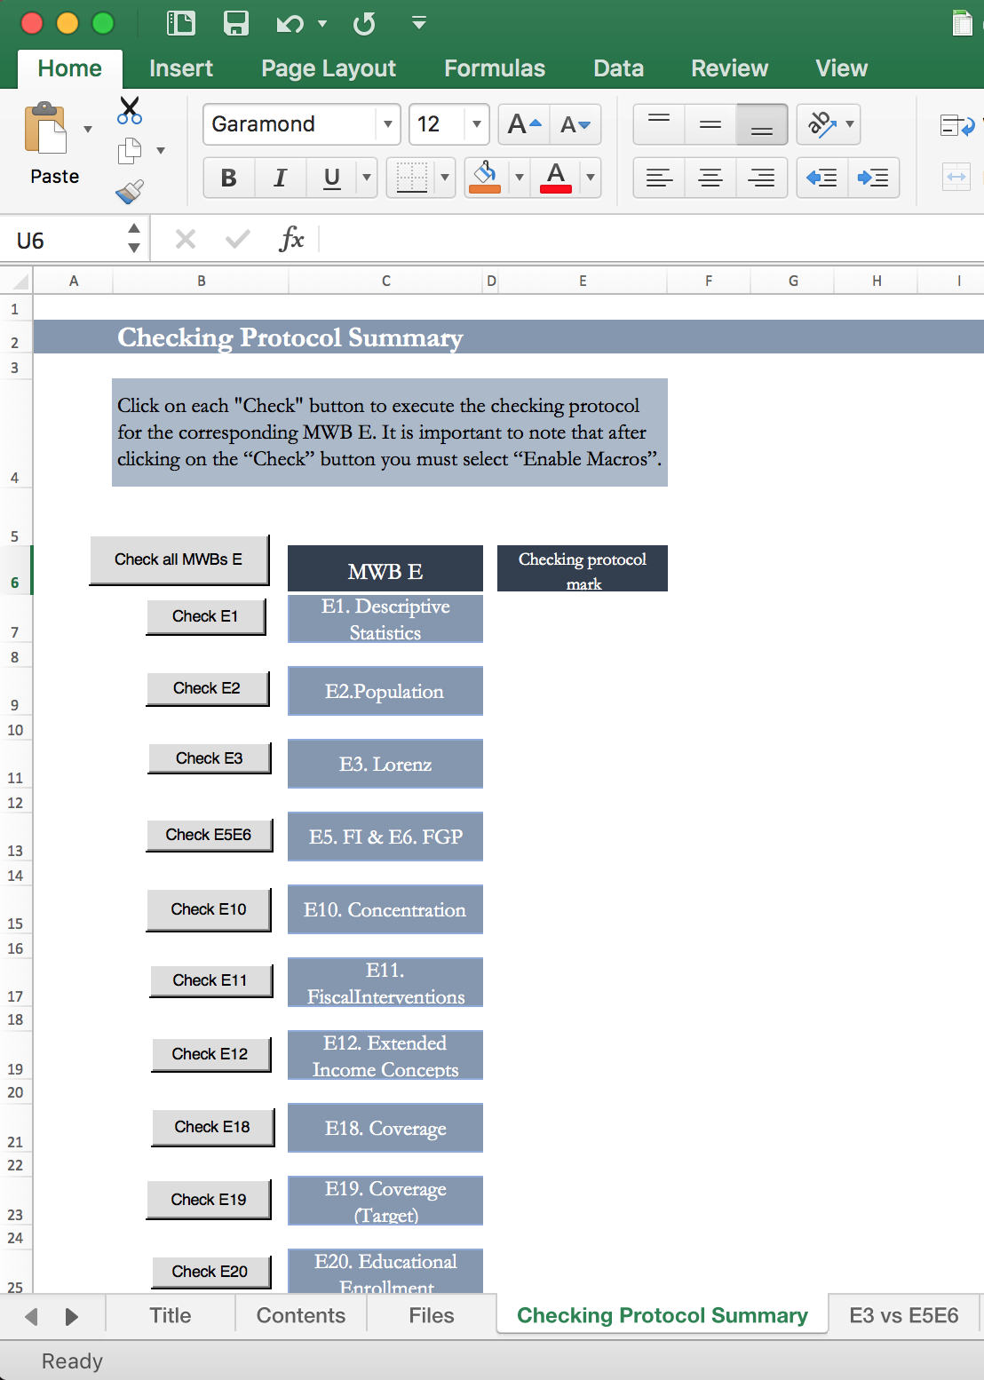

* 1. Using the "Checking Protocol” sheet placed in each MWB E, click on the "Checking" button.

Example for MWB E1:

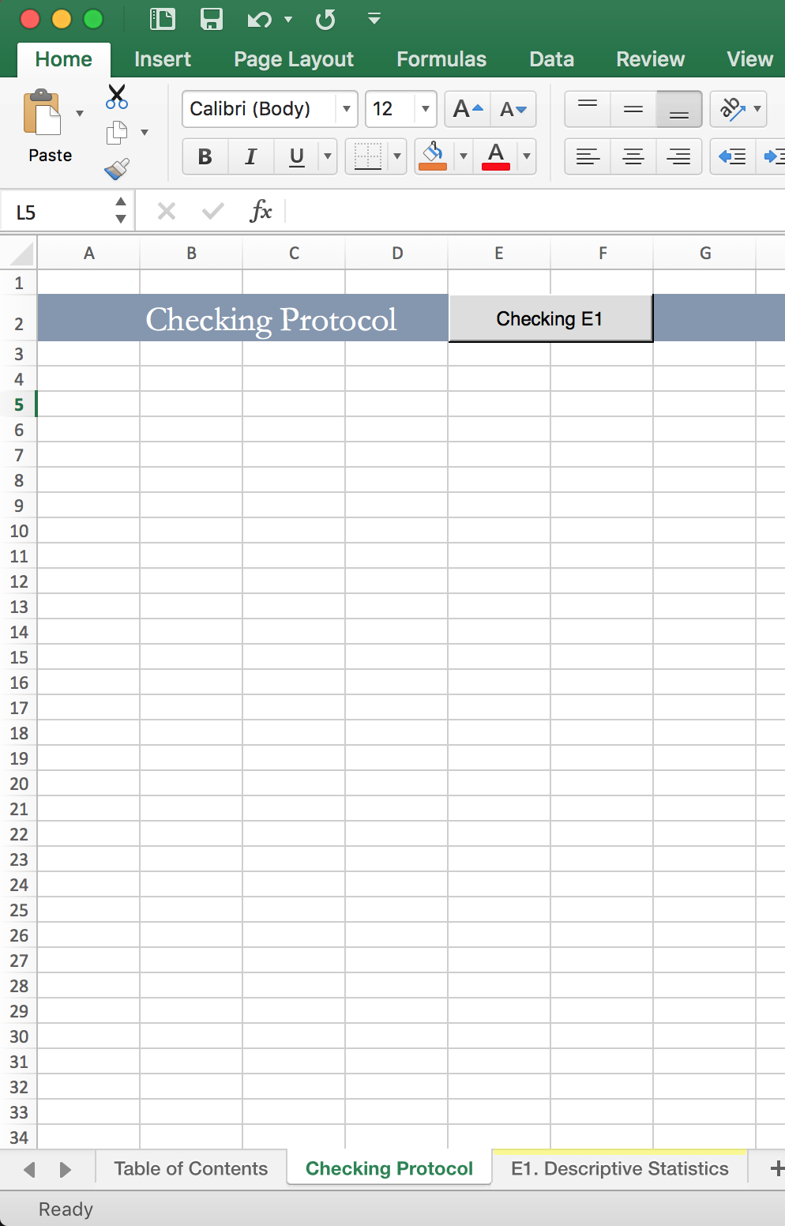

1. Assess if corrective actions are needed.
   1. If you chose option a) in the previous step:
      1. Look at column E of the sheet "Checking Protocol Summary" to see whether each sheet passed the checking protocol or not.
      2. Go to the "Checking protocol" sheet of section E of the MWB that did not pass the checking protocol. Here you can read the notes of caution corresponding to the values considered deserving of revision.
   2. If you chose option b):
      1. Look at the sheet "Checking protocol" and read the notes of caution corresponding to the values considered deserving of revision.

#### For All E sheets

* + - 1. Verify that all the data presented in the banner (row 3) are accurate and complete. Each should include information on:
         1. Country
         2. Year of the survey utilized in the study. If the survey spans more than one year (e.g. 2010-2011) make sure that:

The team chose one year for currency amounts and PPP conversions and explained why this year was chosen.

All the currency amounts are adjusted to the chosen year.

For example, in Brazil the household survey was conducted in 2008-2009. The team should thus ask themselves: "Since the survey was conducted between 2008 and2009, is there a reason for deciding on year or the other for the assessment? Were all currency amounts converted to 2009 currency, either before the survey was released or by the team doing the analysis?" In the case of Brazil, the authors responded: "yes, all currency amounts were converted to 2009 currency before the survey data was released." Hence the team selected 2009 as the year of the survey for their PPP conversions.

* + - * 1. Authors names.
        2. Date of the MWB.
        3. PPP conversion factor. This factor should be consistent with what you get running the ceqppp command or from the World Bank’s World Development Indicators. This check can be done either through Stata or manually:

Running the ceqppp command in Stata.

Run the command. Below is an example for Chile, with the year of study being 2013 and the base year of PPP is 2011.

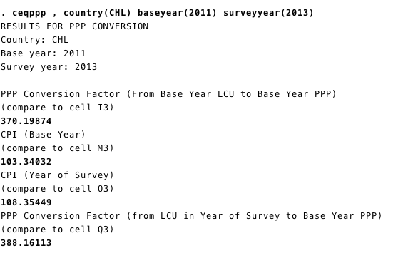

Check if the outputs in the window are the same as the PPP conversion factor in row 3 of sheet you are checking.

Manual check using the World Development Indicators website (WDI):

Collect the PPP conversion factor for 2011 or 2005 (depending on which PPP base year is being used in the analysis).

Collect the Consumer Price Index (CPI) for the year of the survey and the year of the conversion factor (2005 or 2011).

Data for this can be found at:

International Dollar Conversion Factor 2005

(<http://data.worldbank.org/indicator/PA.NUS.PRVT.PP.05?page=1>)

International Dollar Conversion Factor 2011 **(USE YEAR 2011)**

(<http://data.worldbank.org/indicator/PA.NUS.PRVT.PP> )

Consumer Price Index (CPI)

(<http://data.worldbank.org/indicator/FP.CPI.TOTL>)

Calculate the conversion factor using the following equation:

The result of the PPP conversion factor should also be available in:

MWB BV: Sheet A.3 Government Spending and Taxation Cell C22.

Ethno-Racial Workbook: Sheet: Linked Info Cell C8 or C10 (depending on if one is using 2005 or 2011).

* + - * 1. Scenario: This makes reference to additional sensitivity analyses.
        2. Group: This can be National, Urban, Rural, Indigenous, etc.
        3. Project: This normally makes reference to who financed the project.

Check that all the information provided in the sheet “Title” matches the information contained in the name of the Excel file.

#### E1. Descriptive Statistics

1. **Completeness**
   1. Check that all fiscal interventions that are included in sheet C1 are included here as well.
2. **Accuracy/Coherence**
   1. Automated Checking protocol:
      1. Run the checking protocol including the “Cross Check” component (for a detailed description see “Automated Checking Protocol” section). Running the checking protocol will highlight the values that are considered deserving of revision of the MWB under analysis. When the checking protocol detects potential errors, it automatically writes warning messages in the “Checking Protocol” sheet of each MWB E.
      2. Check the warning messages. Messages and their corresponding highlighted colors are as follows:

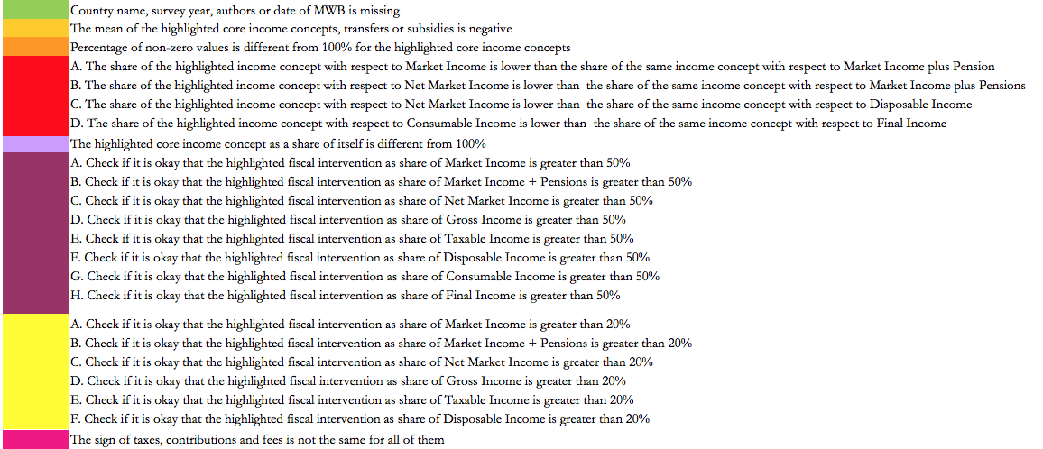

* 1. Check that basic indicators for fiscal interventions and income concepts (average tax rate, min, max, mean) make sense (EUROMOD, 2017).

### E2. Population for Core Income Concepts

1. **Completeness**
   1. Make sure that the information is complete.
2. **Accuracy/Coherence**
   1. Automated Checking protocol:
      1. Run the checking protocol including the “Cross Check” component (for a detailed description see “Automated Checking Protocol” section). Running the checking protocol will highlight the values that are considered deserving of revision of the MWB under analysis. When the checking protocol detects potential errors, it automatically writes warning messages in the “Checking Protocol” sheet of each MWB E.
      2. Check the warning messages. Messages and their corresponding highlighted colors are as follows:

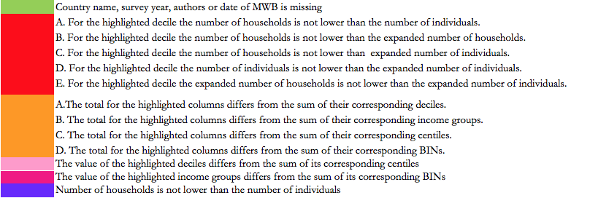

### E3. Lorenz for Core Income Concepts

1. **Completeness**
   1. Make sure that the information is complete.
2. **Accuracy/Coherence**
   1. Automated Checking protocol:
      1. Run the checking protocol including the “Cross Check” part (for a detailed description see “Automated Checking Protocol” section). Running the checking protocol will highlight the values that are considered deserving of revision of the MWB under analysis. When the checking protocol detects potential errors, it automatically writes warning messages in the “Checking Protocol” sheet of each MWB E.
      2. Check the warning messages. Messages and their corresponding highlighted colors are as follows:

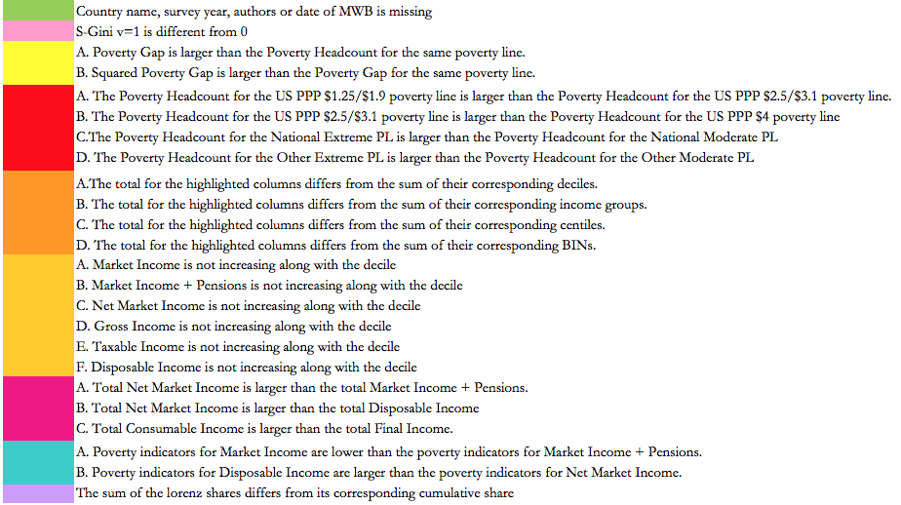

### E4. Inequality of Opportunity for Core Income Concepts

1. **Completeness**
   1. Make sure that the information is complete.
   2. Shapley values may be blank.
2. **Accuracy/Coherence**
   1. Check that in row 5, the circumstances are pre-determined factors that are not dependent on an individual’s effort. These can include items such as race, gender, parents’ education, parents’ income, etc.
   2. Numbers should be very small because they are in logs. For a detailed description of the indicator see Chapter 8 of the CEQ Handbook.
   3. If the proportion of inequality explained by unequal opportunities decreases from net market to disposable income but increases from disposable to consumable income, this would indicate that direct transfers have an equalizing impact on ex ante opportunities, but indirect taxes and subsidies have an unequalizing effect. Analyze if the results make sense.

### E5. Fiscal Impoverishment

1. **Completeness**
   1. Make sure that the information is complete.
2. **Accuracy/Coherence**
   1. Automated Checking protocol:
      1. Run the checking protocol including the “Cross Check” component (for a detailed description see “Automated Checking Protocol” section). This will highlight the values that are considered deserving of revision of the MWB under analysis. When the checking protocol detects potential errors, it automatically writes warning messages in the “Checking Protocol” sheet of each MWB E.

Check the warning messages. Messages and their corresponding highlighted colors are as follows: 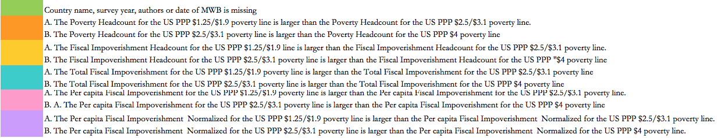

### E6. Fiscal Gain to the Poor

1. **Completeness**
   1. Make sure that the information is complete.
2. **Accuracy/Coherence**
   1. Automated Checking protocol:
      1. Run the checking protocol including the “Cross Check” component (for a detailed description see “Automated Checking Protocol” section). This will highlight the values that are considered deserving of revision of the MWB under analysis. When the checking protocol detects potential errors, it automatically writes warning messages in the “Checking Protocol” sheet of each MWB E.
      2. Check the warning messages. Messages and their corresponding highlighted colors are as follows:

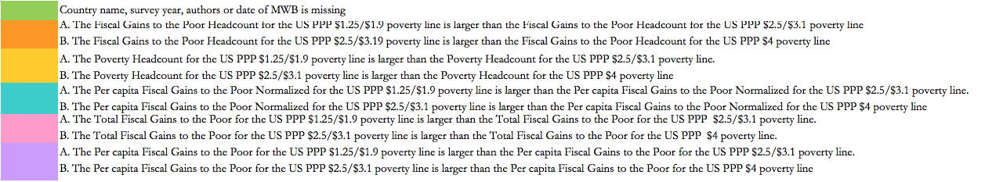

#### E9. Effectiveness Indicators for Core Income Concepts

1. **Completeness**
   1. Make sure that the information is complete.
2. **Accuracy/Coherence**
   1. CEQ Impact Effectiveness need to be between -1 and 1.
   2. CEQ Spending Effectiveness should be between 0 and 1.
   3. Beckerman Imervoll Effectiveness Indicators should be between 0 and 1.

### E10. Concentration Values for Core Income Concepts

1. **Completeness**
   1. Make sure that the information is complete.
2. **Accuracy/Coherence**
   1. Automated Checking protocol
      1. Run the checking protocol including the “Cross Check” component (for a detailed description see “Automated Checking Protocol” section). This will highlight the values that are considered deserving of revision of the MWB under analysis. When the checking protocol detects potential errors, it automatically writes warning messages in the “Checking Protocol” sheet of each MWB E.
      2. Check the warning messages. Messages and their corresponding highlighted colors are as follows:

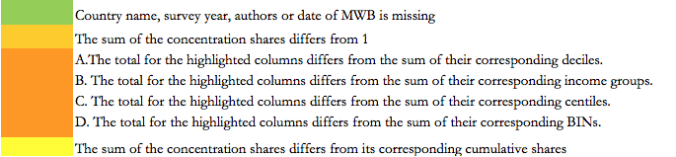

### E11. Fiscal Interventions Concentration Values (One for each core income concept)

1. **Completeness**
   1. Make sure that the information is complete.
   2. Make sure all fiscal interventions in Sheet C1 are listed on this sheet. They should also match the fiscal interventions listed on sheets E1 and E12.
2. **Accuracy/Coherence**
   1. Automated Checking protocol:
      1. Run the checking protocol including the “Cross Check” component (for a detailed description see “Automated Checking Protocol” section). This will highlight the values that are considered deserving of revision of the MWB under analysis. When the checking protocol detects potential errors, it automatically writes warning messages in the “Checking Protocol” sheet of each MWB E.
      2. Check the warning messages. Messages and their corresponding highlighted colors are as follows:

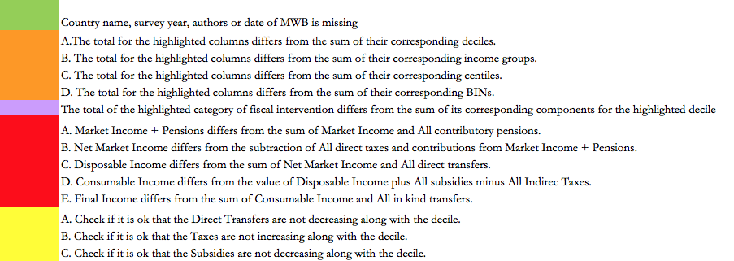

### E12. Lorenz for Extended Income Concepts

1. **Completeness**
   1. Make sure that the information is complete.
   2. Make sure all fiscal interventions listed on sheet C1 are also listed on this sheet. They should also match with the fiscal interventions listed on sheets E1 and E11.
2. **Accuracy/Coherence**
   1. Automated Checking protocol:
      1. Run the checking protocol including the “Cross Check” component (for a detailed description see “Automated Checking Protocol” section). This will highlight the values that are considered deserving of revision of the MWB under analysis. When the checking protocol detects potential errors, it automatically writes warning messages in the “Checking Protocol” sheet of each MWB E.
      2. Check the warning messages. Messages and their corresponding highlighted colors are as follows:

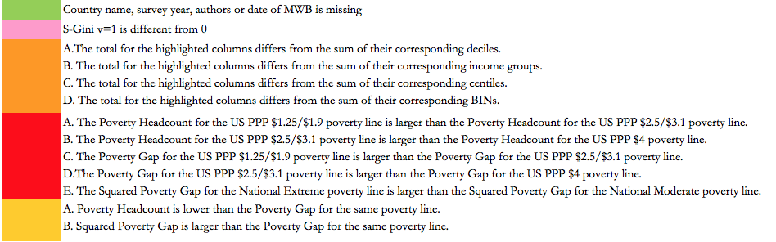

### E13. Marginal Contributions, Size & Marginal Effects

1. **Completeness**
   1. Make sure that the information is complete.
2. **Accuracy/Coherence**
   1. Relative Size with respect to each income concept should be consistent with the information on Sheet E11.
   2. Concentration coefficients and the Kakwani Index should be consistent with the information on Sheet 11.
   3. Marginal Contribution to Redistributive Effect should be the same value that you get from E12 when you calculate it manually.
      1. Marginal Contribution to Vertical Equity + Marginal Contribution to Reranking= Marginal Contribution of the end income. For example, cells D18+D19 of sheet “E13.d Marg. Contrib.” =cell E12 of sheet “E13.c Marg. Contrib.”
   4. Marginal contributions to poverty must match the results of their respective calculations using the information available on Sheet E12.

### E14. Effectiveness

1. **Completeness**
   1. Make sure that the information is complete.
   2. Note that CEQ Spending Effectiveness and Beckerman Imervoll Effectiveness Indicators are not calculated for taxes.
2. **Accuracy/Coherence**
   1. CEQ Impact Effectiveness needs to be between -1 and 1 for direct and indirect transfers and subsidies. Should be between -1 and 0 for taxes and fees.
   2. CEQ Spending Effectiveness should be between 0 and 1.
   3. Beckerman Imervoll Effectiveness Indicators should be between 0 and 1

### E18. Coverage

1. **Completeness**
   1. Make sure that the information is complete.
2. **Accuracy/Coherence**
   1. Automated Checking protocol:
      1. Run the checking protocol including the “Cross Check” component (for a detailed description see “Automated Checking Protocol” section). This will highlight the values that are considered deserving of revision of the MWB under analysis. When the checking protocol detects potential errors, it automatically writes warning messages in the “Checking Protocol” sheet of each MWB E.
      2. Check the warning messages. Messages and their corresponding highlighted colors are as follows:

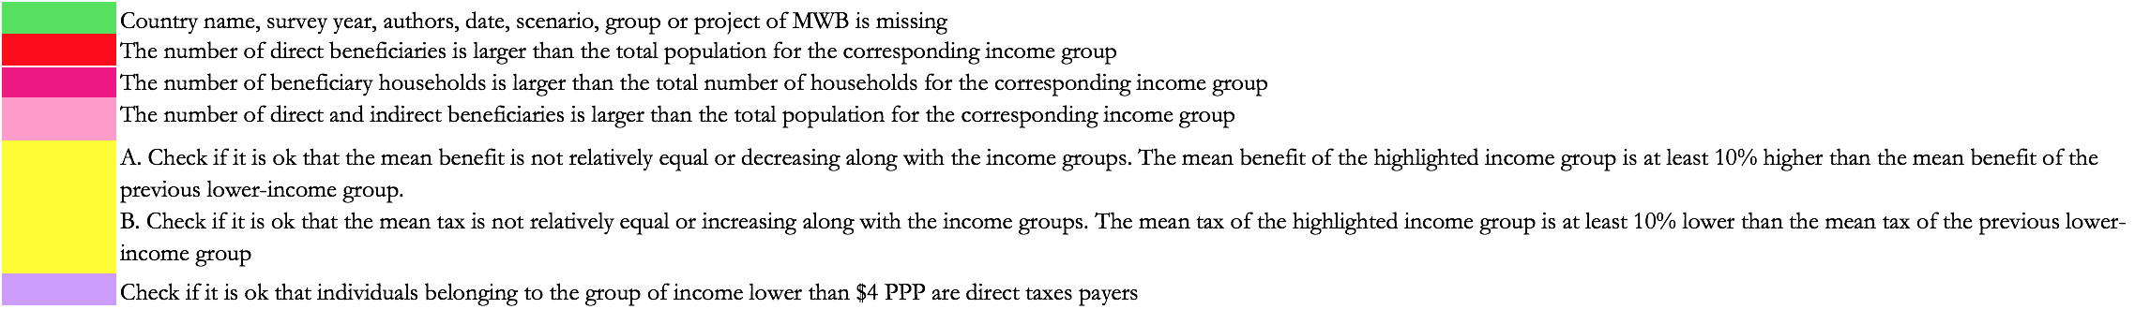

### E19. Coverage (target)

1. **Completeness**
   1. Make sure that the information is complete.
   2. Make sure all fiscal interventions listed here are listed on Sheet C1. They should also match the fiscal interventions listed on Sheets E1 and E11.
2. **Accuracy/Coherence**
   1. Automated Checking protocol:
      1. Run the checking protocol including the “Cross Check” component (for a detailed description see “Automated Checking Protocol” section). This will highlight the values that are considered deserving of revision of the MWB under analysis. When the checking protocol detects potential errors, it automatically writes warning messages in the “Checking Protocol” sheet of each MWB E.
      2. Check the warning messages. Messages and their corresponding highlighted colors are as follows:

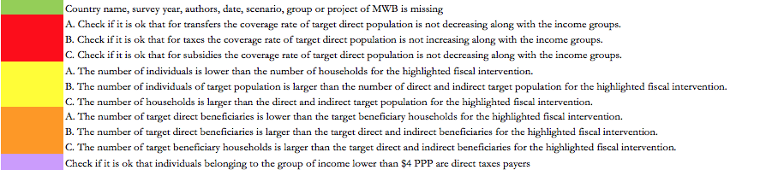

### E20. Educational Enrollment

1. **Completeness**
   1. Make sure that the information is complete.
2. **Accuracy/Coherence**
   1. Automated Checking protocol:
      1. Run the checking protocol including the “Cross Check” component (for a detailed description see “Automated Checking Protocol” section). This will highlight the values that are considered deserving of revision of the MWB under analysis. When the checking protocol detects potential errors, it automatically writes warning messages in the “Checking Protocol” sheet of each MWB E.
      2. Check the warning messages. Messages and their corresponding highlighted colors are as follows:

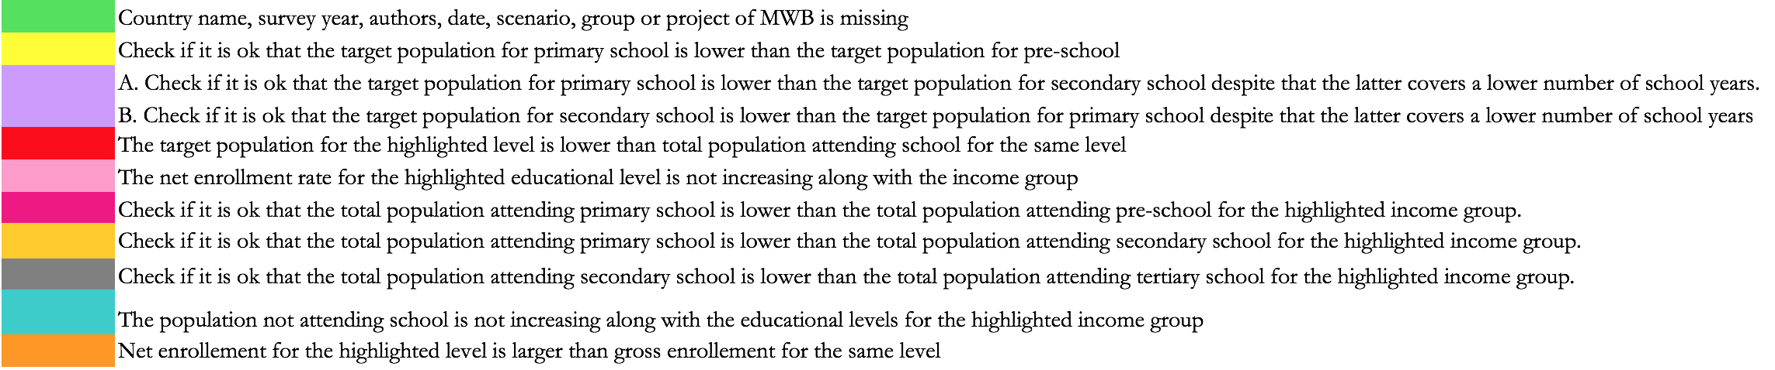

### E21. Infrastructure Access

1. **Completeness**
   1. Make sure that the information is complete.
   2. Make sure all programs listed on Sheet C1 are also listed in row 8 and vice versa. They should also match the programs listed on Sheets E1 and E11.
2. **Accuracy/Coherence**
   1. Automated Checking protocol:
      1. Run the checking protocol including the “Cross Check” component (for a detailed description see “Automated Checking Protocol” section). This will highlight the values that are considered deserving of revision of the MWB under analysis. When the checking protocol detects potential errors, it automatically writes warning messages in the “Checking Protocol” sheet of each MWB E.
      2. Check the warning messages. Messages and their corresponding highlighted colors are as follows:

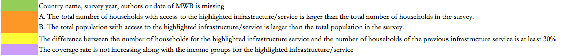

### E22. Household Socio-Demographic Indicators

1. **Completeness**
   1. Make sure that the information is complete.
   2. It is up to the author what information should be added to this sheet.

### E23. Individual Socio-Demographic Indicators

1. **Completeness**
   1. Make sure that the information is complete.
   2. It is up to the author what information should be added to this sheet.

### E24. Lorenz Curves

1. **Completeness**
   1. Graphs of pre- and post-fisc Lorenz and concentration curves to assess progressivity should be included.
   2. The ceq Stata command ceqgraph progressivity creates 4 graphs.
2. **Accuracy/Coherence**: if the system is equalizing (unequalizing) the post-fiscal Lorenz should be closer to (further from) the diagonal than the Pre-Fisc Lorenz.

### E25. Concentration Curves

1. **Completeness**
   1. Graphs of concentration curves of fiscal interventions ranked by each core income concept should be included.
   2. The ceq Stata command ceqgraph conc creates sets of 4 graphs, one set where you have the summary of the fiscal interventions and other sets where you can see the fiscal interventions disaggregated.
2. **Accuracy/Coherence**:concentration curves of fiscal interventions with a negative (positive) concentration coefficient should be above (below) the diagonal.

### E26. Cumulative Distribution Functions

1. **Completeness**
   1. Graphs of cumulative distribution functions of the CEQ core income concepts should be included.
   2. The ceq Stata command ceqgraph cdf creates one graph with the 8 core income concepts included.
2. **Accuracy/Coherence**:
   1. Population share increases along with the income, but at a decreasing rate. A typical income cdf will have a positive but small slope near the origin; the slope will become steeper and steeper as one moves left to right (along the x-axis from the poorest to richer households), and then the slope will remain positive but decrease in magnitude near the top-end of the income range. In other words, the 2nd derivative of the cdf is first positive and then negative. See the figure below.

Figure 1

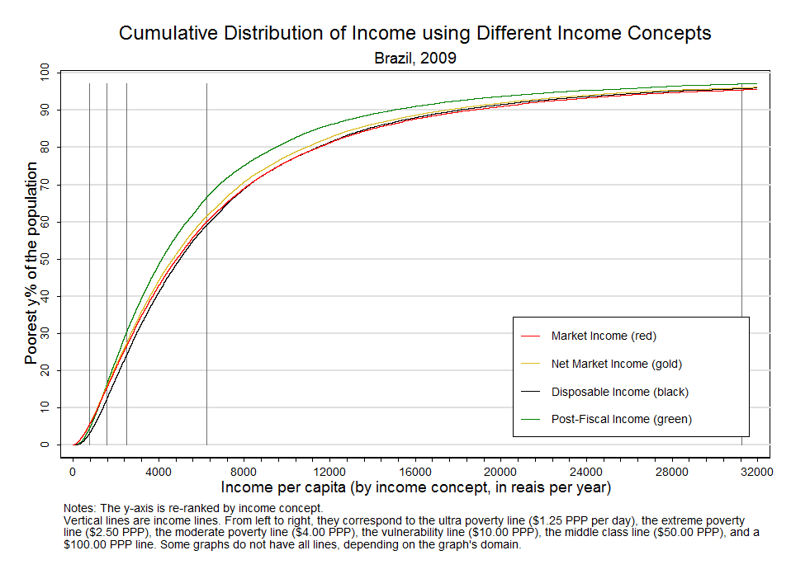

### E27. Fiscal impoverishment and gains to the poor curves

1. **Completeness**
   1. Graphs of fiscal impoverishment (FI) and fiscal gains to the poor (FGP) measures should be included.
   2. The ceq Stata command ceqgraph fi creates sets of 4 graphs per kind (headcount, normalized, per capita, and total).
2. **Accuracy/Coherence**
   1. FI and FGP should increase along with the poverty line, but you should see a decreasing rate. See figure below.

Figure 2

FI and FGP curves

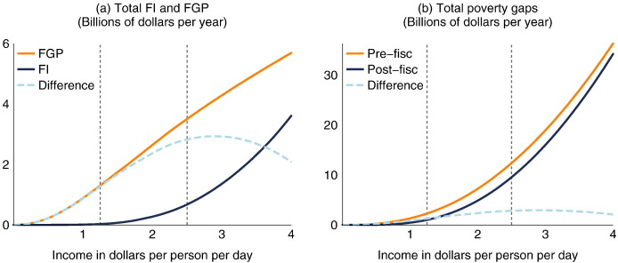

Source: Higgins & Lustig (2013)

### E28. Assumption Testing

E28 is meant to test the assumptions used to construct the income concepts and compare the implications of these assumptions on a limited number of summary measures (the mean, median, standard deviation, Gini, Theil, 90/10, and poverty using various poverty lines and the headcount, poverty gap, and squared poverty gap, as well as totals by decile and income group).

Check that the indicators -- mean, median, standard deviation, Gini, Theil, 90/10, and poverty-- move in the expected direction depending on the assumption tested. For example if you want to compare market income plus pensions and market income in order to see the effect of contributory pensions, you would expect the mean of market income to be lower than the mean of market income plus pensions, the sum of market income to be lower than the sum of market income plus pensions, the poverty rate of market income to be larger than market income plus pensions, the Gini to be larger, etc.

# References

Euromod. 2017. “EUROMOD Modelling Conventions” EUROMOD Technical Note Series 1.0. Colchester: Institute for Social and Economic Research, University of Essex.

Higgins, Sean and Nora Lustig. 2013. Measuring Impoverishment: An Overlooked Dimension of Fiscal Incidence. CEQ Working Paper 14, Center for Inter-American Policy and Research and Department of Economics, Tulane University and Inter-American Dialogue, April.

Lustig, Nora and Sean Higgins. 2018. “The CEQ Assessment: Measuring the Impact of Fiscal Policy on Inequality and Poverty,” Chapter 1 in Commitment to Equity Handbook. Estimating the Impact of Fiscal Policy on Inequality and Poverty, edited by Nora Lustig (Brookings Institution Press and CEQ Institute, Tulane University). Advance online version available at http://www.commitmentoequity.org/publications/handbook.php.

# ANNEX 1

## Instructions on how to use the “Linking” program

Section D contains the summary of the CEQ assessment results presented in Section E of the MWB and produced by the ceq Stata package. Section D can be fully completed using the visual basic programs embedded in the excel files “MWB2017_D_[scenario]_[date]” The Linking procedure was developed to facilitate the data extraction from the CEQ Master Workbook (MWB) part E and compile the information into the main results tables, specifically MWB_ABCD part D. Summary Results.

1. Enable “Macros”/ “Contents”
   1. 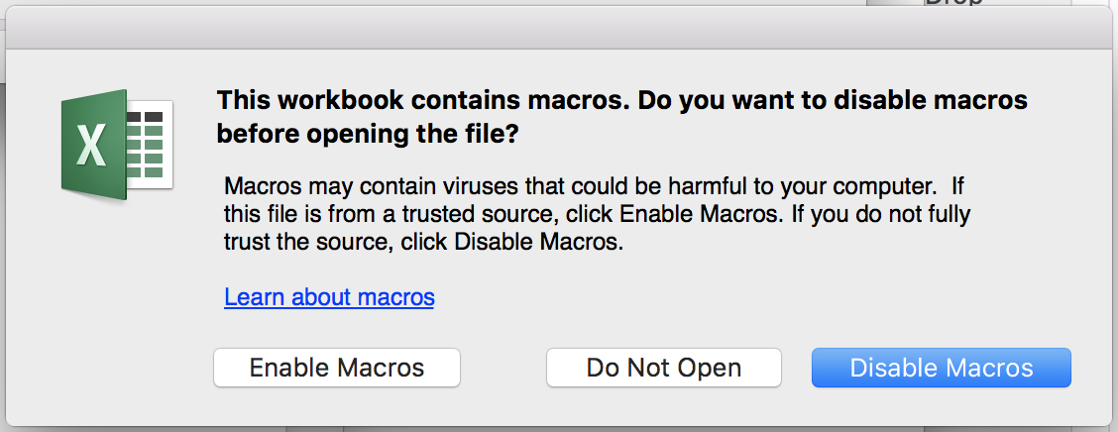Mac users: Open the *MWB2017_D_PDI* file or *MWB2017_D_PGT* file (depending on which scenario the user is working on) and then click on the **“Enable Macros”** button once the warning window is displayed.
   2. Windows users: The user has to enable Macros in her/his PC to execute the linking by clicking on **“Enable Contents”;** otherwise the program will not work.
2. Fill the “Linking” sheet in:
   1. Write the directory path where the different MWBs Excel Sheets E are located on the first text box. All the files of the MWB part E must be located in the same folder.

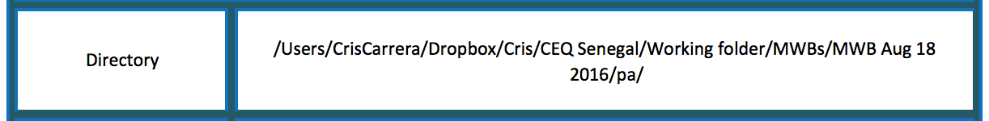

* 1. Specify the name and extension of each MWB E (see the example below).

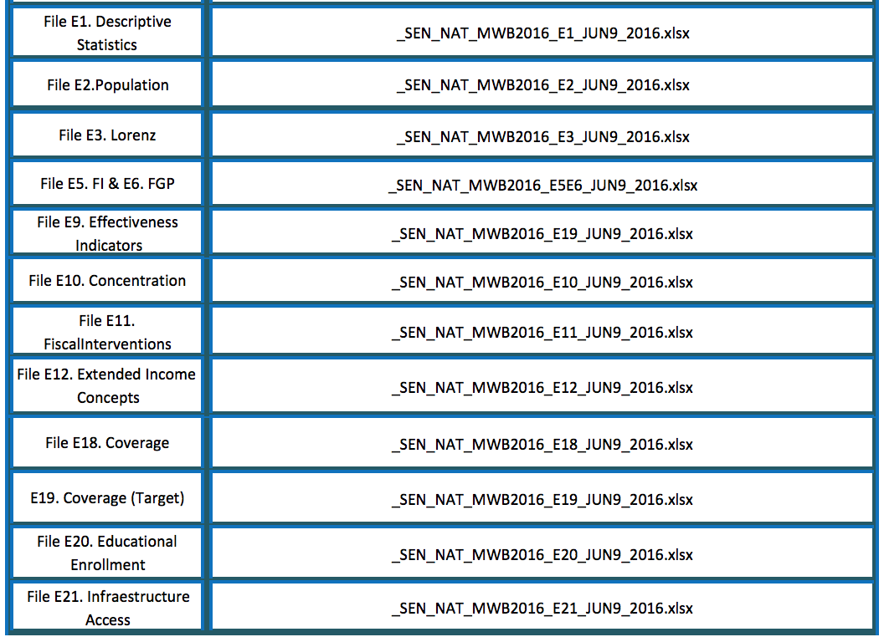

1. Select the operating system: next to the table where the directory path and files were inserted, the user has to select the operating system (Windows or iOS),
2. Verify that all the files and directory path are correct by clicking on the **“Accept”** button.
   1. iOS users: Sometimes, Mac operating systems ask for additional permissions to access the files. In order to grant the access, the user has to click on the “Select…” button and then select “Grant Access” option.

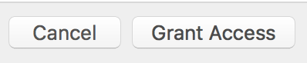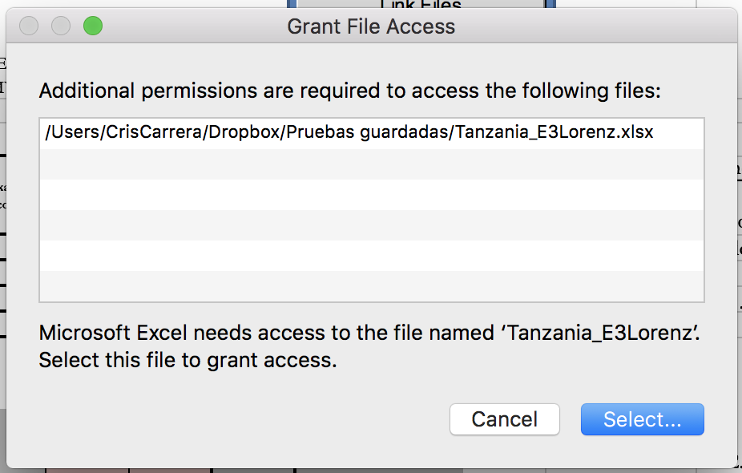

Note: The window “Grant File Access” will appear more than once depending on the number of files needed to extract the information and fill in the tables of the sheet on which the user is working.

1. Click on the **“OK”** button: If the directory path, the files name and extensions were correct, a confirmation box will be displayed.

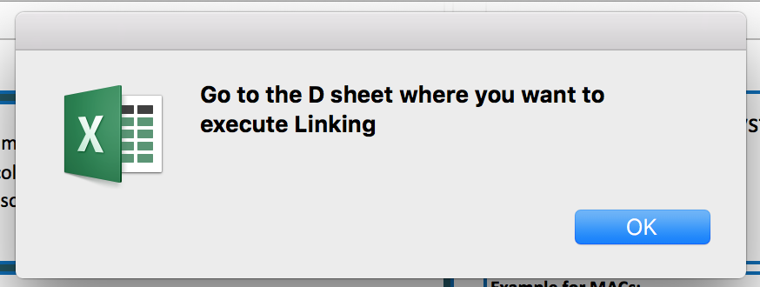

If a window with the label **“Directory could not be found”** or **“File could not be found”** appears instead, then the user has to click on the **“OK”** button and repeat the procedure from Step 2 using the correct directory path and file information.

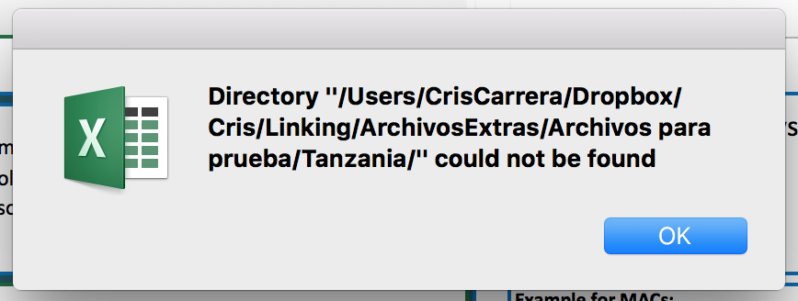 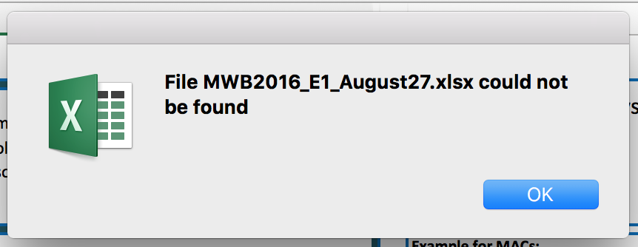

1. Go to the D sheet that you want to link
2. Click on **“Link Files”,** wait a few seconds while the program executes the macros and voilá! Enjoy analyzing your results.

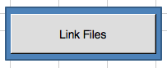

1. The indicators are described in chapters 1, 3, 4, 5 and 8 of the Handbook. Tables and graphs are produced using the CEQ Stata package, a user-written suite of Stata commands.
2. Lustig and Higgins (2018)
3. ISO three letter country code refers to alphabetic International Standard Organization (ISO) country codes, available at https://www.iso.org/obp/ui/#search